**ASSIGNMENT 2 FRONT SHEET**

|  |  |  |  |
| --- | --- | --- | --- |
| **Qualification** | **BTEC Level 5 HND Diploma in Computing** | | |
| **Unit number and title** | PROG102: Procedural Programming | | |
| **Submission date** |  | **Date Received 1st submission** |  |
| **Re-submission Date** |  | **Date Received 2nd submission** |  |
| **Student Name** | Bùi Hương Linh | **Student ID** | GBH200662 |
| **Class** | GCH1002 | **Assessor name** | Đỗ Tiến Thành |
| **Student declaration**  I certify that the assignment submission is entirely my own work and I fully understand the consequences of plagiarism. I understand that making a false declaration is a form of malpractice. | | | |
|  |  | **Student’s signature** |  |

**Grading grid**

|  |  |  |  |  |
| --- | --- | --- | --- | --- |
| P4 | P5 | M3 | M4 | D2 |
|  |  |  |  |  |

|  |  |  |
| --- | --- | --- |
| **❒ Summative Feedback:                                                                 ❒ Resubmission Feedback:** | | |
| **Grade:** | **Assessor Signature:** | **Date:** |
| **Lecturer Signature:** | | |

Contents

I/ Introduction: 4

I.1/ Problem : 4

I.2/ Solution: 4

I.3/ Procedural programming: 4

I.3.1/ What is the procedural programming? 4

I.3.2/ Characteristies: 4

II/ Implementation: 5

III/ Progrem results: 10

IV/ Testing: 14

V/ Evaluation & Conclution: 15

Bibliography 15

# I/ Introduction:

## I.1/ Problem :

A math teacher wants to manage grades of a class. The math teacher wants to make a student

transcript and submit it to the school. Based on the transcript, the university can classify students

according to merit, good, average,ect.

## I.2/ Solution:

The school has expressed an opinion that it wants an application that can help teachers solve this

problem easily and effectively. This application will contribute to solving the problems that users

face.

## I.3/ Procedural programming:

### I.3.1/ What is the procedural programming?

Procedural programming (POP) is where the major focus on performing tasks in a sequential order. It divides a large program into small functional blocks or functions for ease of programming and testing easier.(Learn Computer Science,2021)

### I.3.2/ Characteristies:

- Focus on the work to be done (algorithms).

+ Helps beginners can improve their mindset about solving problems.

- Large program is divided into subroutines, each of which can be called one or more times in any order.

+It makes it easier for programmers to address problems since faults in each sub-program may be readily fixed.

- Most functions use common data.

- Data in the system is moved from one function to another.

+ Programmers can manage data easily.

- Uses immutable data.(  [Leonila Cordrey](https://popularask.net/author/leonila-cordrey/),2021)

# II/ Implementation:

+ #include<stdio.h> : Get various functions to perform input and output.

+ #include<stdlib.h> :

+ #include<conio.h> : Perform input and output operations from the screen.

+ Struct: Used to declare student objects with properties or program manager.

* int: Used to store student object with attributes such as id, name,gender,age,ect.
* float: Used to declare subjects, average scores, highest, lowest of student. Because when entering points, there may be commas, we have to use float.
* char name,gender: Use for entering name, gender of student, [50] is limit of characters.

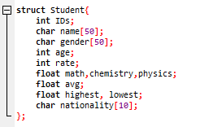

+ ST: Stands for student.

* &st: Declared to pass a parameter.
* a: array declares struct st.

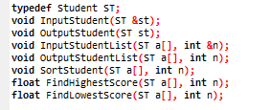

+ int main : Where the show starts.

* int n: Enter student integer.
* Do-while: Used for the user to enter the correct condition of ‘n’.
* ST a[n]: declare variable ‘ST’, variable ‘n’ array ‘a’.
* Create a menu:

1. Enter student list

2. Export student list

3. Sort the student's score

4. Highest score

5. Lowest score

0. Exit program

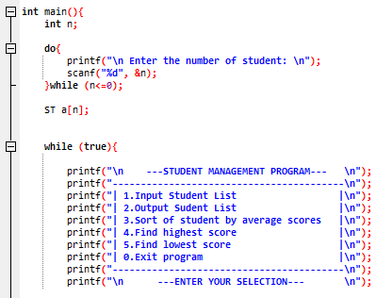

+Switch case: Using switch case statement to create the menu.

* op: create a op variable.

call back the declared function.

* Input Student List (a,n)
* Output Student List(a,n)
* getch(): to stop the screen.
* break: end

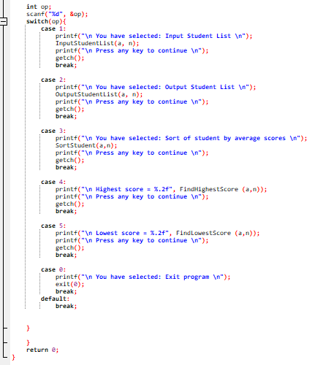

+ Do-while: Used to perform the previous job and check the following condition.

First, enter 3 points of math, physics, chemistry. if you enter math, physics, chemistry scores between 0 and10, the program will continue to run. Conversely, if you enter math < 0 or physics < 0 or chemistry < 0 or math > 10 or physics > 10 or chemistry > 10, the program forces the user to re-enter the score.

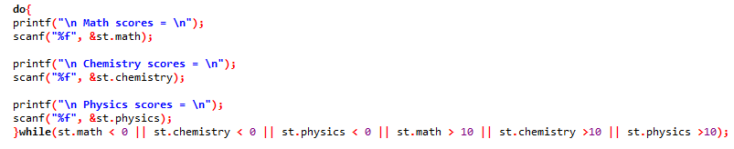

+If-else: Use used to make right and wrong decisions when implementing algorithms.

If the average score is less than 6.5, the student is rankes as average. else if the average score is < 8 and the average score is >= 6.5, the student is ranked as good. Conversely, the student is ranked as excellent.

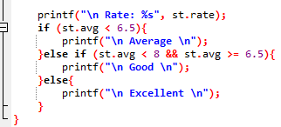

+for loop: Use ‘int’ for ‘i’ to traverse data from first element to last element.

* Initials value highest=a[1].avg. Browse the elements of the array in turn. If an element has the highest value, we proceed to assign that value to the highest. For each element, compare it with 'highest'. If 'highest' is lower than the element of the array, assign it temporarily to that particular element which is the array.
* Initials value highest=a[1].avg. Browse the elements of the array in turn. If an element has the lowest value, we proceed to assign that value to the lowest. For each element, compare it with 'lowest'. If 'lowest' is raiser than the element of the array, assign it temporarily to that particular element which is the array.

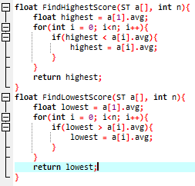

+ void: Return null function.

* Use the for loop structure to enter students in order. Here, I use 'i+1' because 'student' is never 0 students. It always starts with the first student.
* Use the for loop structure to export students in order.

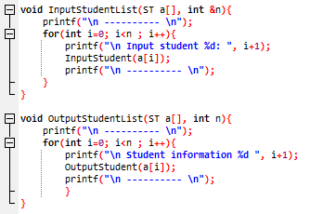

# III/ Progrem results:

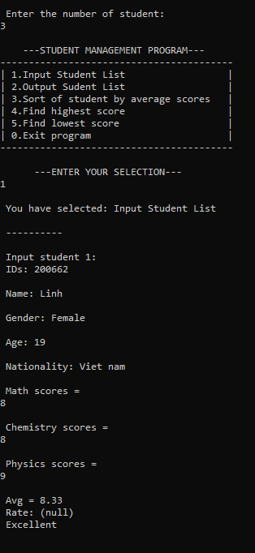

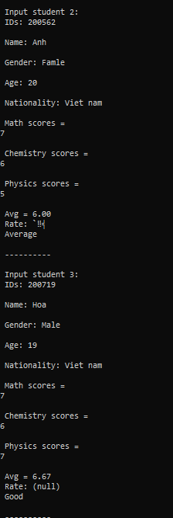

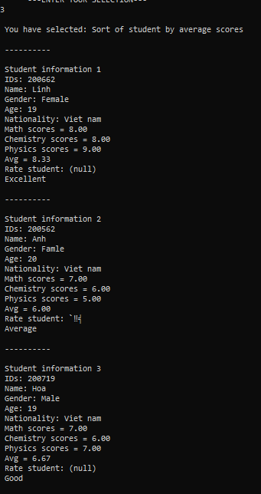

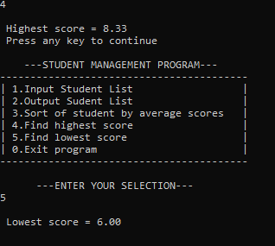

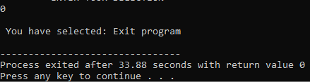

# IV/ Testing:

|  |  |  |  |  |  |  |
| --- | --- | --- | --- | --- | --- | --- |
| Test | Test Description | Test Steps | Test Data | Expected Results | Actural Results | Pass/Fall |
| 1 | Used to import student list and calculate the average of three subjects. | 1. Enter  2. Input data of student | id: 200662  Name: Linh  Gender:Female  Age:19  Math:7  Chemistry:8  Physics:9  Avg=8.00  Rate:Excellent | Input Student List | Successfull | Pass |
| 2 | Export the list entered case 1 | 1.Enter 2  2.Output Student List | Id:200662  Name: Linh  Gender:Female  Age:19  Math:7  Chemistry:8  Physics:9  Avg=8.00  Rate:Excellent | Show id,name, age, etc. enter in case 1 | Successfull | Pass |
| 3 | Sort of student by average score | 1.Enter 3  2.Sort average score | Id:200662  Name: Linh  Gender:Female  Age:19  Math:7  Chemistry:8  Physics:9  Avg=8.00  Rate:Excellent | Show average score | Successfull | Pass |
| 4 | Find highest score | 1.Enter 4  2.Highest score | Highest score: 8.00 | Show highest score | Successful | Pass |
| 5 | Find lowest score | 1.Enter 5  2.Lowest score | Lowest score:6.5 | Show lowest score | Successfull | Pass |
| 0 | Exit | 1.Enter  2.Exit(0) | 0 | Exit program | Successful | Pass |

# V/ Evaluation & Conclution:

I think my program is not very good, need to change some places to be more suitable.

Through creating this student management program I have learned a lot about coding. it helped me improve my background knowledge, understand more about how functions, variables, statements, and loops are used.

In terms of advantages, the functions and algorithms are quite simple and the program is not too complicated. The program runs very simple and fast.

In terms of challenges, several interlocking structures and processes make program development complicated and the app has some bugs that I can't fix.

In the future, I will write a more complete student management software with many functions based on the designed algorithms.

I hope that the program I created can help teachers and schools manage students more effectively.In the future, I hope, I can write a perfect student management program.

# Bibliography

(2021, 10 28). Retrieved from learncomputerscienceonline.com: https://www.learncomputerscienceonline.com/procedural-programming/

Cordrey, L. (2021, 10 29). Retrieved from popularask.net: https://popularask.net: https://popularask.net/which-of-the-following-is-a-main-characteristic-of-procedural-programming-language/?fbclid=IwAR1EOdIZqEnRmfwDA15-V1zZHECGGma92dS13gFxfN8_yiPUP5unXvtaX8M